Git version control with Eclipse

Table of Contents

1. [Installation of Git support into Eclipse](http://www.vogella.com/tutorials/EclipseGit/article.html#installation-of-git-support-into-eclipse)
2. [Git user settings in Eclipse](http://www.vogella.com/tutorials/EclipseGit/article.html#git-user-settings-in-eclipse)
3. [Configuring the toolbar and the menu for Git usage](http://www.vogella.com/tutorials/EclipseGit/article.html#configuring-the-toolbar-and-the-menu-for-git-usage)
4. [Working with Eclipse projects in a Git repository](http://www.vogella.com/tutorials/EclipseGit/article.html#working-with-eclipse-projects-in-a-git-repository)

[4.1. Adding a new project to a local Git repository](http://www.vogella.com/tutorials/EclipseGit/article.html#adding-a-new-project-to-a-git-repository)

[4.2. Adding a new project to a remote Git repository](http://www.vogella.com/tutorials/EclipseGit/article.html#adding-a-new-project-to-a-git-repository)

[5. Import(clone) projects from an remote GIT repository](http://www.vogella.com/tutorials/EclipseGit/article.html#import-projects-from-an-existing-repository)

[7. Performing Git operations in Eclipse](http://www.vogella.com/tutorials/EclipseGit/article.html#performing-git-operations-in-eclipse)

[7.1. Pull, push and fetch](http://www.vogella.com/tutorials/EclipseGit/article.html#pull-push-and-fetch)

[7.2. Basic team operations](http://www.vogella.com/tutorials/EclipseGit/article.html#basic-team-operations)

[7.3. Team operations available on the project](http://www.vogella.com/tutorials/EclipseGit/article.html#team-operations-available-on-the-project)

[7.4. Amending a commit](http://www.vogella.com/tutorials/EclipseGit/article.html#amending-a-commit)

[8. Branching in Eclipse](http://www.vogella.com/tutorials/EclipseGit/article.html#branching-in-eclipse)

[9. Starting a merge operation in Eclipse](http://www.vogella.com/tutorials/EclipseGit/article.html#starting-a-merge-operation-in-eclipse)

[9.1. Merge](http://www.vogella.com/tutorials/EclipseGit/article.html#merge)

[9.2. Solving merge conflicts](http://www.vogella.com/tutorials/EclipseGit/article.html#solving-merge-conflicts)

[10. Rebasing a branch onto another branch](http://www.vogella.com/tutorials/EclipseGit/article.html#rebasing-a-branch-onto-another-branch)

[11. Git reset and Git reflog](http://www.vogella.com/tutorials/EclipseGit/article.html#git-reset-and-git-reflog)

[11.1. Moving the branch pointer with Git reset](http://www.vogella.com/tutorials/EclipseGit/article.html#moving-the-branch-pointer-with-git-reset)

[11.2. Finding "invisible" commits with the Reflog view](http://www.vogella.com/tutorials/EclipseGit/article.html#finding-invisible-commits-with-the-reflog-view)

[12. Using git cherry-pick](http://www.vogella.com/tutorials/EclipseGit/article.html#using-git-cherry-pick)

[13. Creating patches](http://www.vogella.com/tutorials/EclipseGit/article.html#creating-patches)

1. [Installation of Git support into Eclipse](http://www.vogella.com/tutorials/EclipseGit/article.html#installation-of-git-support-into-eclipse):

Most Eclipse IDE distributions from Eclipse.org already contain support for Git. In this case no additional installation is required.

Otherwise you can install it via the Eclipse installation manager. Select the Help ▸ Install new Software…​ menu entry. Enter one of the following update site URL:

<http://download.eclipse.org/egit/updates>

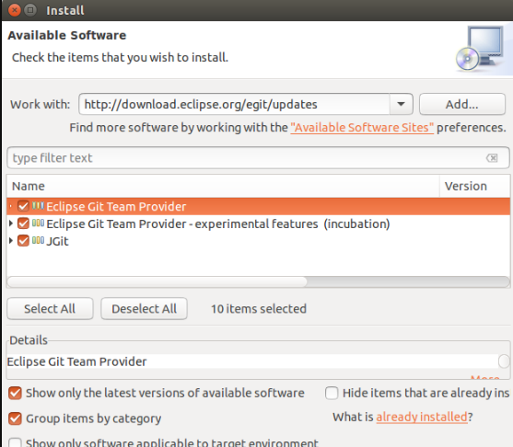

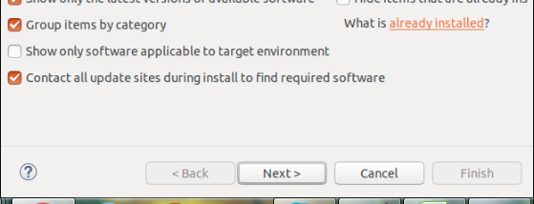

1. [Git user settings in Eclipse](http://www.vogella.com/tutorials/EclipseGit/article.html#git-user-settings-in-eclipse)

To use Git you must configure your full name and email address. This information is used to fill the author and committer information of commits you create. These Git configuration settings can be adjusted via the Eclipse preference setting. Select Window ▸ Preferences ▸ Team ▸ Git ▸ Configuration to see the current configuration and change email address and username.

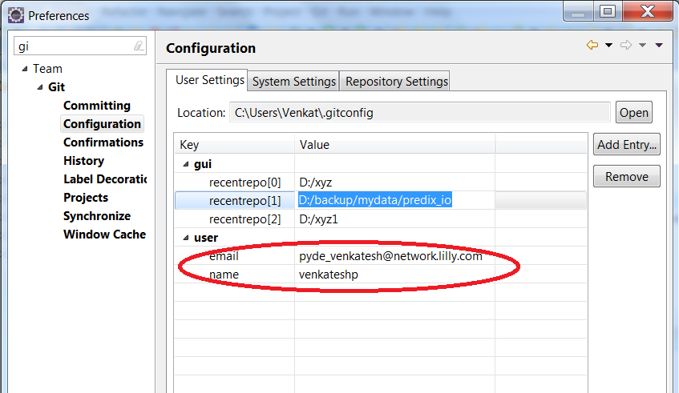

1. [Configuring the toolbar and the menu for Git usage](http://www.vogella.com/tutorials/EclipseGit/article.html#configuring-the-toolbar-and-the-menu-for-git-usage)

To simplify access to the common Git operations you can activate the Git toolbar. For this select Window ▸ Perspective ▸ Customize perspective…​ and check the *Git* and *Git Navigation Actions* entries in the *Action Set Availability*tab.

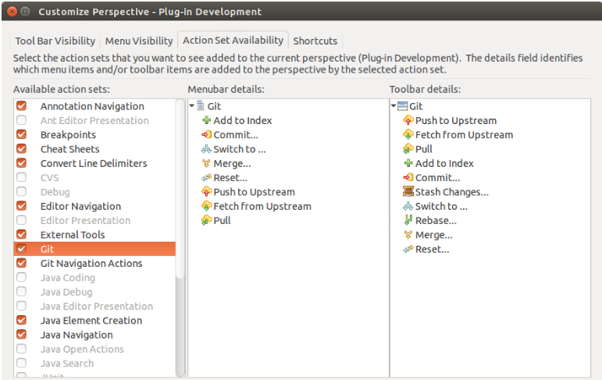



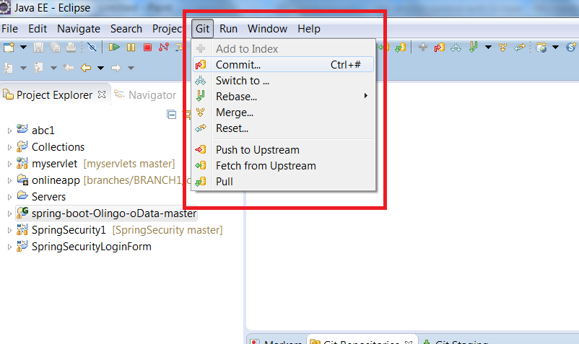

1. [Working with Eclipse projects in a Git repository](http://www.vogella.com/tutorials/EclipseGit/article.html#working-with-eclipse-projects-in-a-git-repository)

[4.1. Adding a new project to a local Git repository](http://www.vogella.com/tutorials/EclipseGit/article.html#adding-a-new-project-to-a-git-repository)

Create sample project and move it to git remote repository.

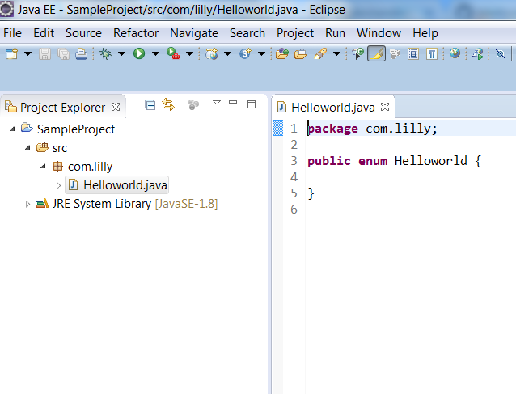

To move above project into GIT remote repository we need to follow below steps.

Step-1:

Right click on project -> Team -> Share project

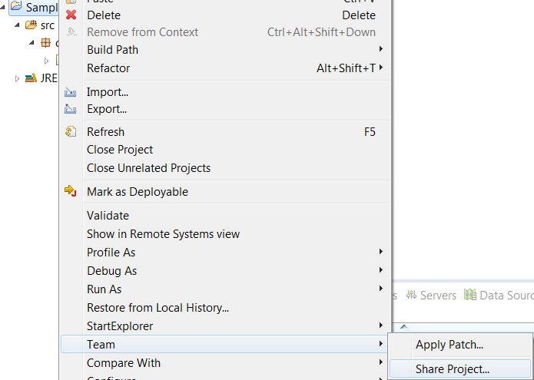

Step2:

Select GIT and click on Next button

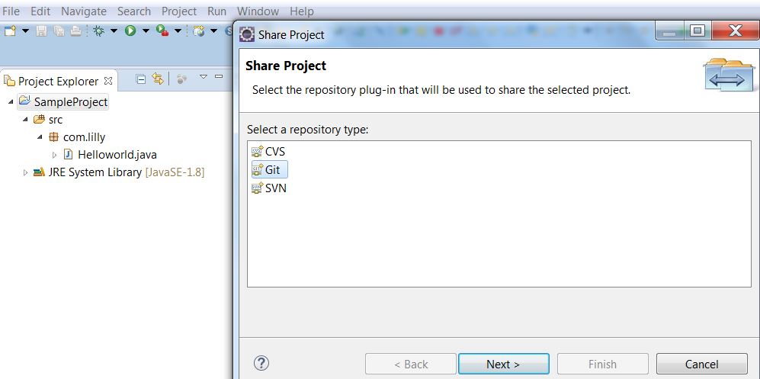

Step3:

Click on create button to provide local repository path.

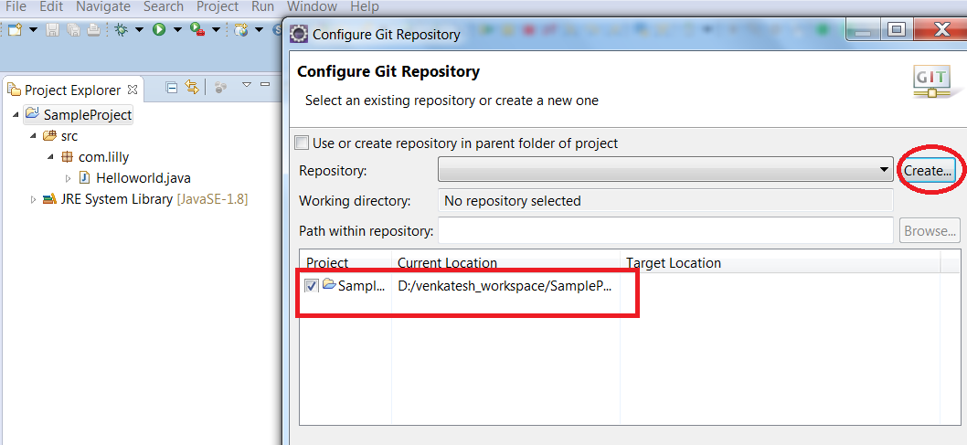

Step4:

Browse local repository location and click on finish.

Local repository can be any path in local system.

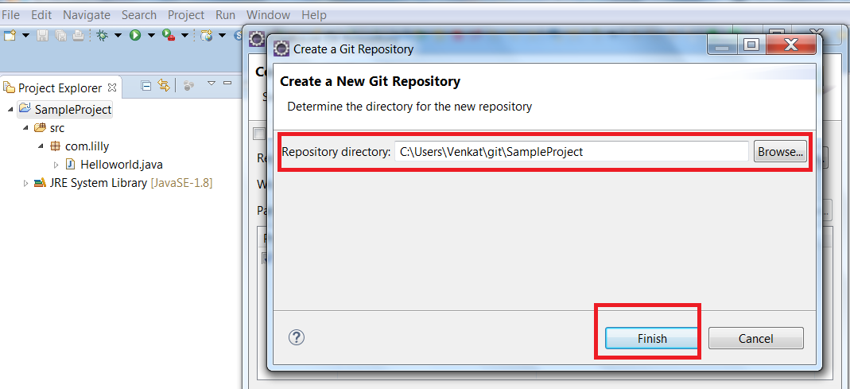

Step5:

Click on finish button to create local repository

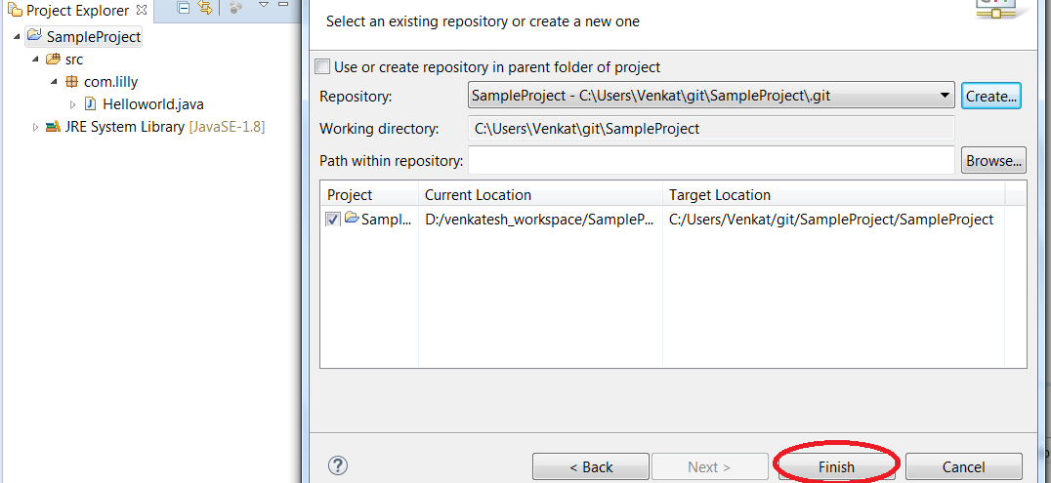

Step6:

Open git repositories to view the project in local repository.

*Windows -> show view -> other.. -> expand git -> select git repositories*

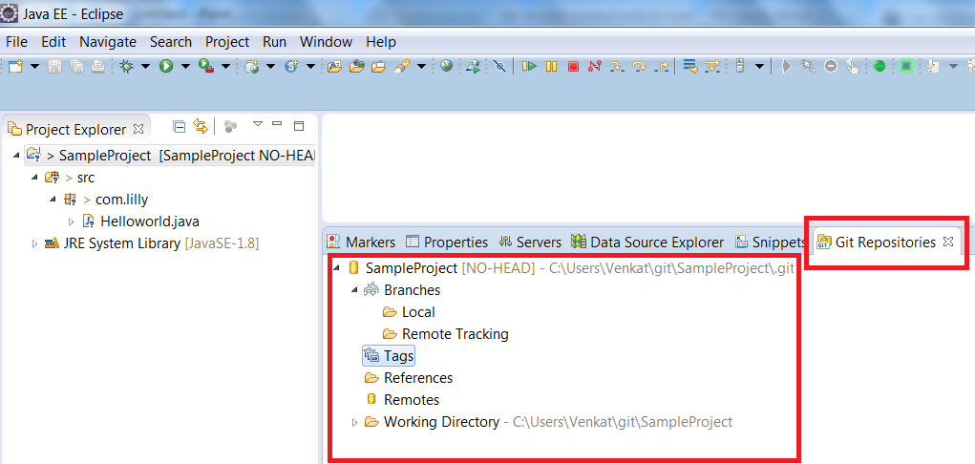

Step7:

Now move complete project from eclipse to local repository and to we need to follow

Below step.

Right click project -> Team -> Commit

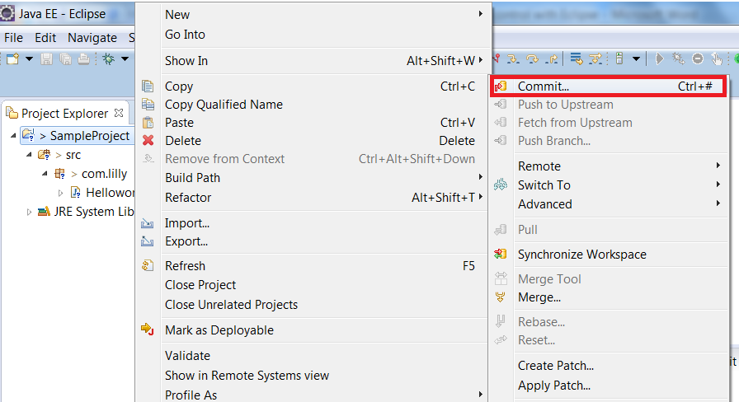

Select all files and enter proper comment and finally click on commit button.

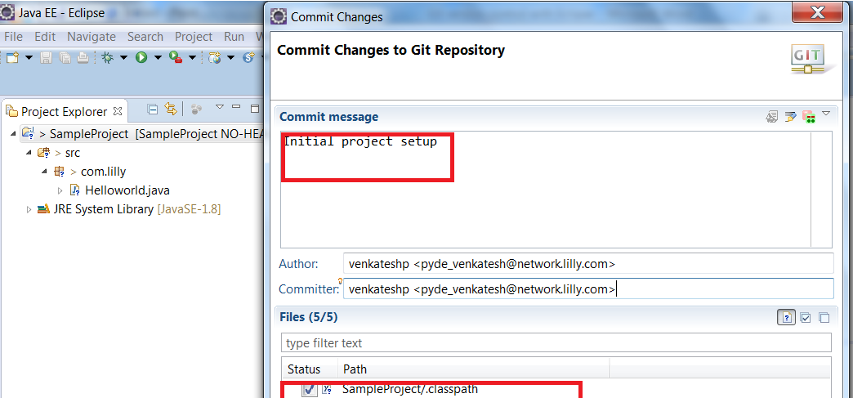

Now verify in Git repositories view for local repo project.

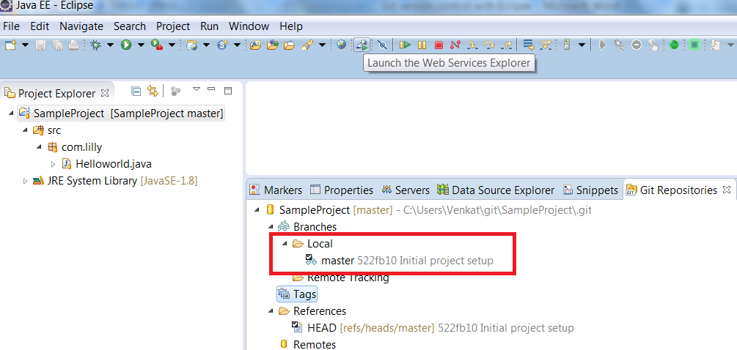

* 1. [Adding a new project to a remote Git repository](http://www.vogella.com/tutorials/EclipseGit/article.html#adding-a-new-project-to-a-git-repository)

To add the above project into GIT remote repository we need to follow below steps,

Before doing this we need remote repository location. Here below is my remote repository location.

<https://github.com/venkateshpyde/SampleProject.git>

Step1:

Right click on remote option in Git Repositroies view and select “Create Remote”

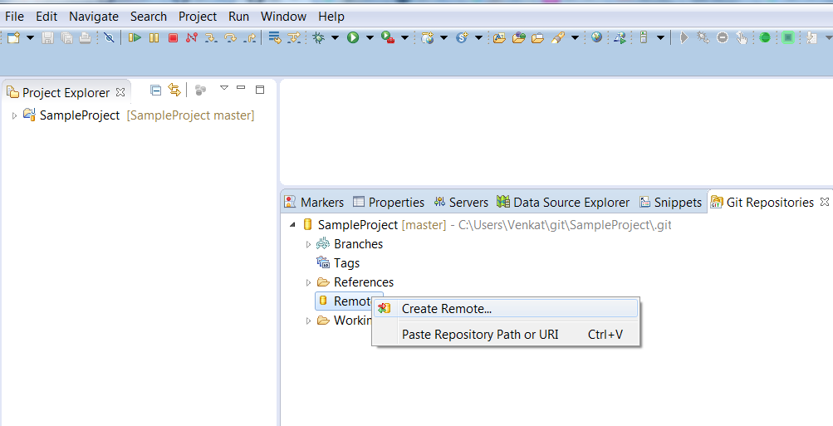

Use default name as origin and select “Configure push” radio button and click on ok

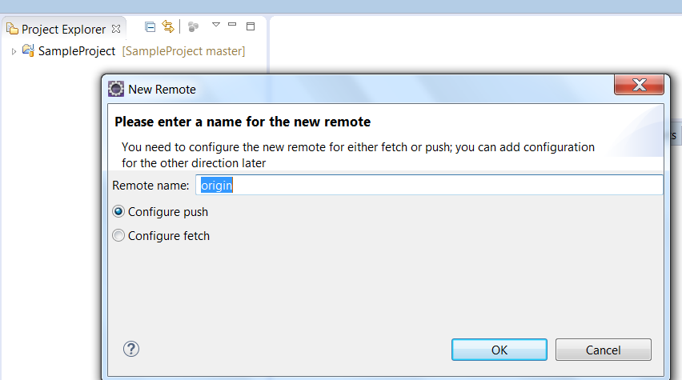

Click on change button and provide GIT url, username and password. And enable Store in Secure store check box to save password in eclipse. And click on finish button.

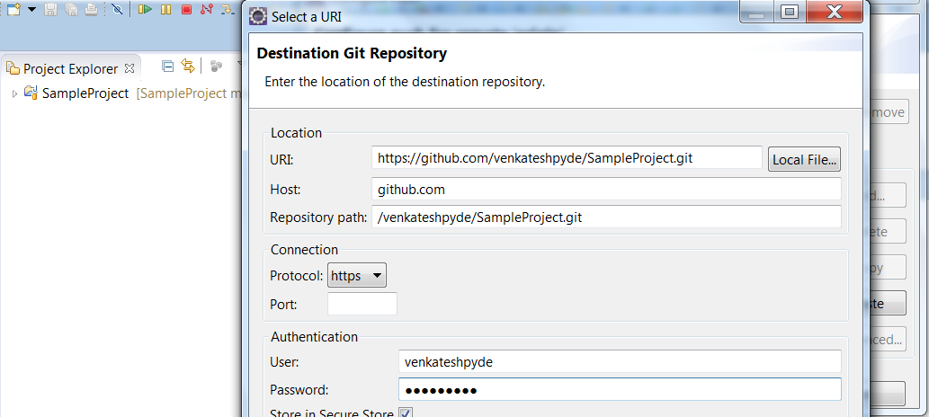

Click on Advanced button, Select Source ref as master[branch] and Destination ref as refs/heads/master and Click on AddSpec and finally click on finish button.

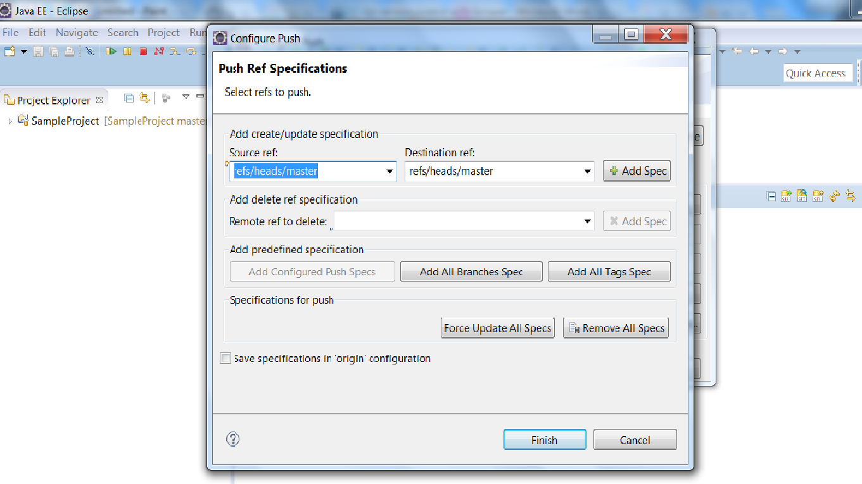

And click on Save button to save configurations.

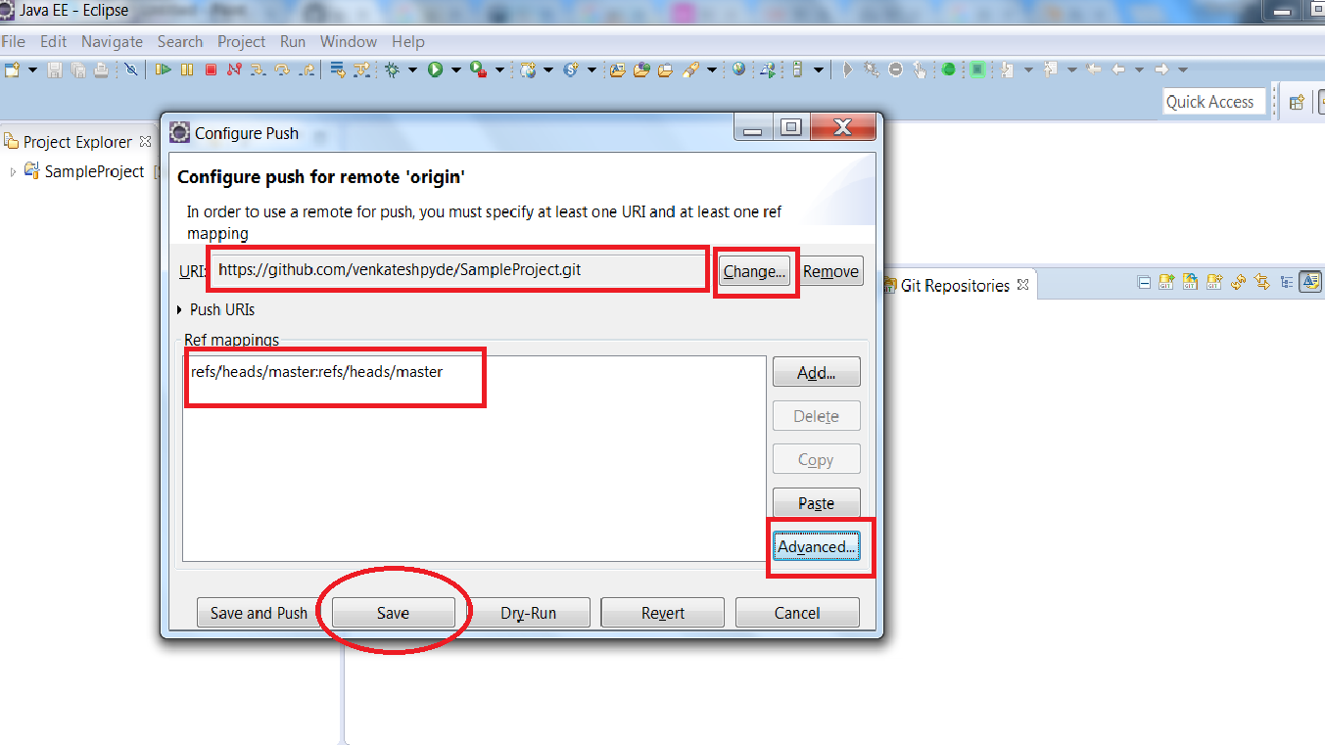

Now check remote option in GIT repositories view for remote git repository location.

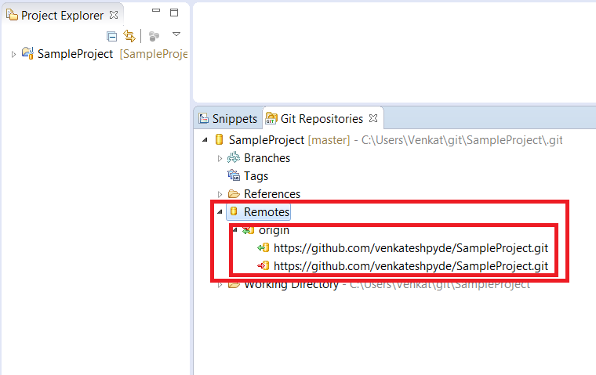

Now push local repository project to remote repository.

Right click on master under local and select Push branch.

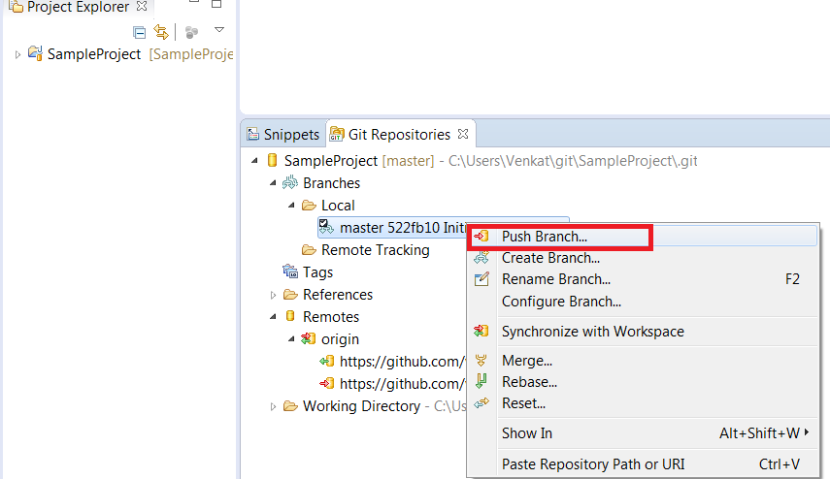

Click on Next.

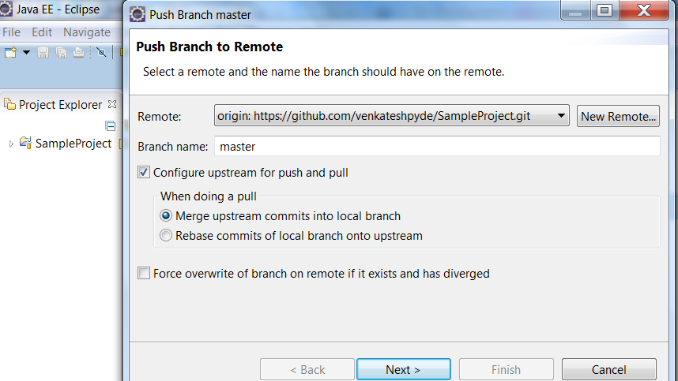

Enter username and password and enable Store in Secure store and click on Ok

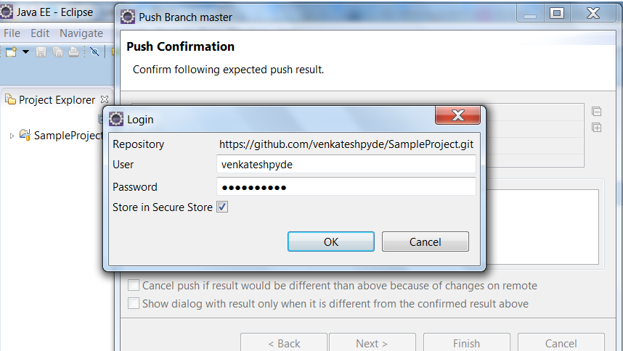

Click on Finish.

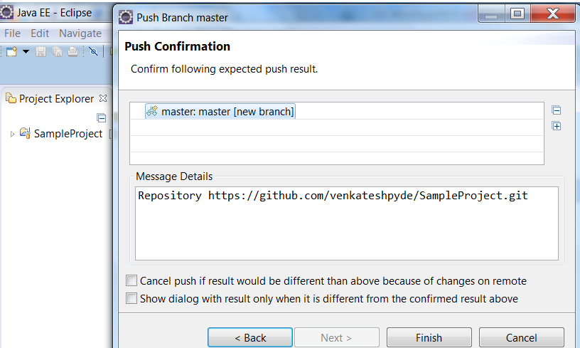

Click on ok.

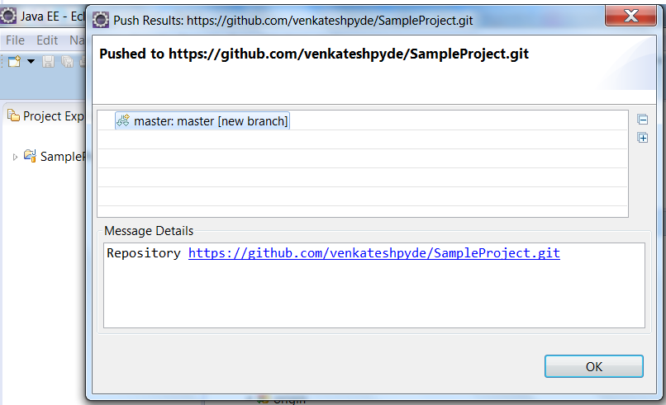

Now verify your project in GIT remote repository.

[5. Import(clone) projects from an remote GIT repository](http://www.vogella.com/tutorials/EclipseGit/article.html#import-projects-from-an-existing-repository)

Before clone remote repository we need project GIT remote repository url and GIT username and password. Follow below steps to import projects from GIT remote repository.

Go to File -> import -> expand git -> select Projects from Git -> Click on Next.

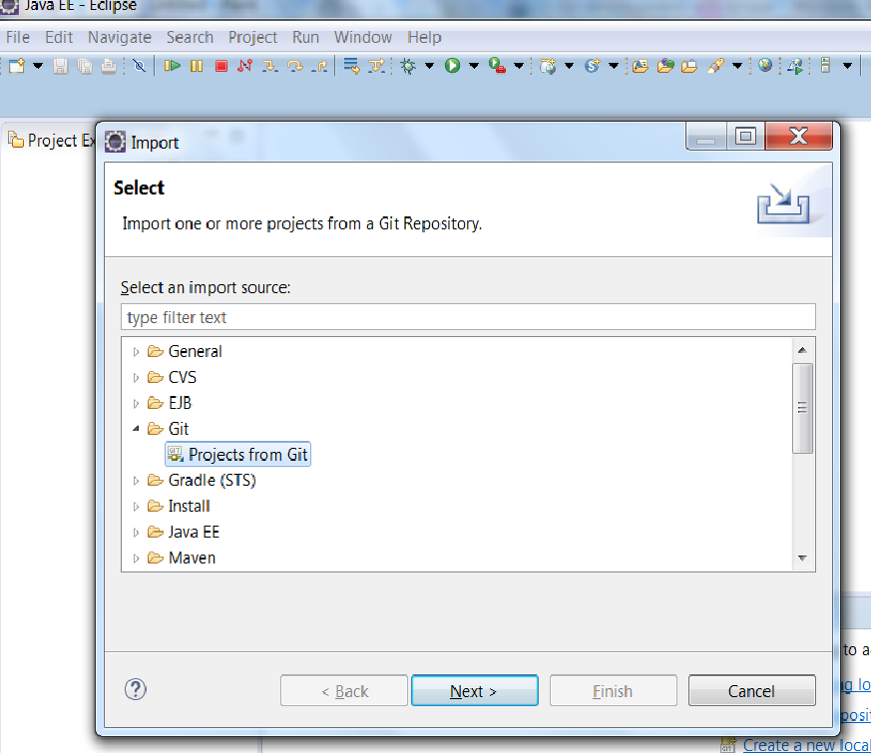

Select Clone URI and click on Next button.

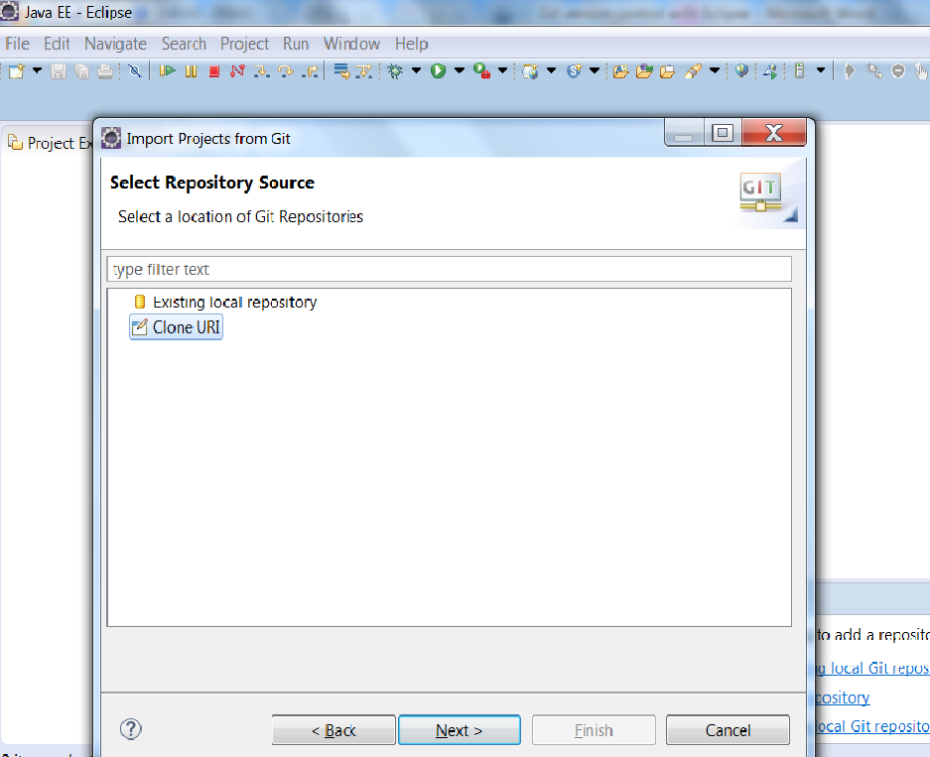

Enter project GIT remote repository url and enter GIT username and password. Make sure enable Store in Secure store. And click on Finish.

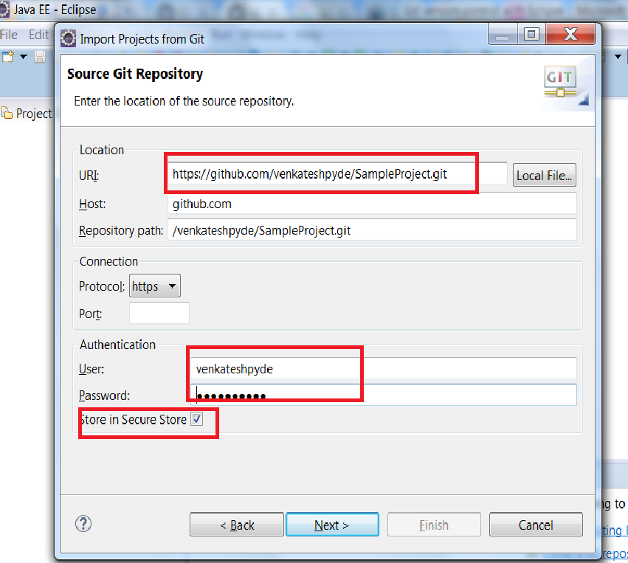

Select appropriate branch and click on Next.

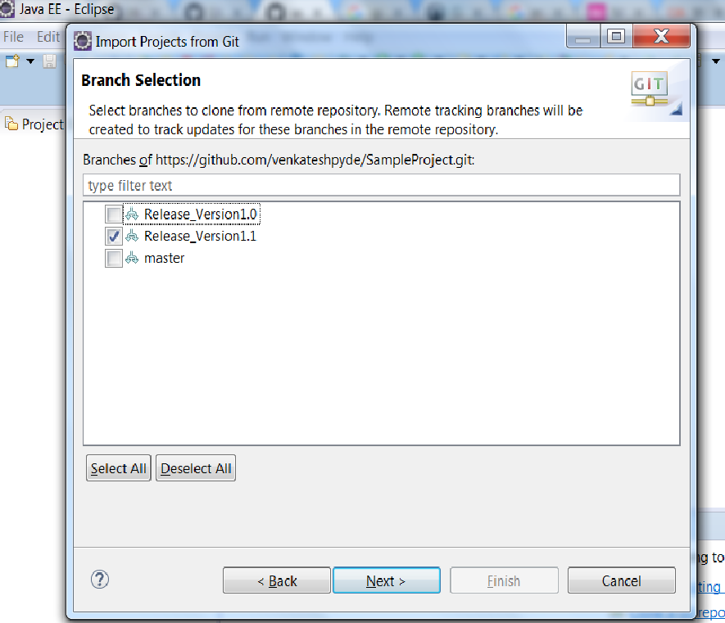

Click on Browse button to choose local repository project location. And click on Next -> Next-> Finish





